RDM630 Specification

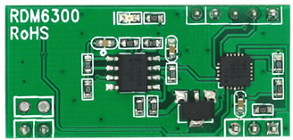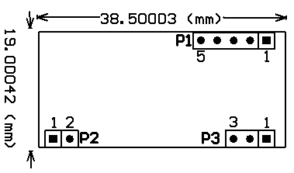
1 Pin definition （TTL interface RS232 data format）：
P1：
PIN1 TX
PIN2 RX
PIN3
PIN4 GND
PIN5 +5V(DC)

P2:
PIN1 ANT1
PIN2 ANT2

P3:
PIN1 LED
PIN2 +5V(DC)
PIN3 GND
Specification and Parameter：
Frequency | 125KHz
Baud Rate | 9600（TTL Electricity Level RS232 format）
interface | TTL Electricity Level RS232 format
Power supply | DC 5V（±5%）
Current | < 50Ma
Operating range | ＞50mm（Depend on Card/Tag shape, manufacturer）
Expand I/O port | N/A
Indication light | N/A
Working temperature | -10℃ ~ +70℃
Storage temperature | -20℃ ~ +80℃
Max. humidity | Relative humidity 0 ~ 95%
Size | 38.5mm×19mm×9mm

TTL Interface RS232 Data output format

  - 9600bps,N,8,1
  - CHECKSUM: card 8 bytes DATA entire do XOR operation

Total is 14 bytes.
0x02 | 2 bytes data | 8 bytes ASCII Data Characters | 1 byte data | Checksum(1 byte) | 0x03

For Example: if you receive the “8 bytes data”:
Output data:30H、31H、32H、33H、34H、35H、36H、37H
30H is ASCII code of 0;
31H is ASCII code of 1
32H is ASCII code of 2;
33H is ASCII code of 3;
34H is ASCII code of 4;
35H is ASCII code of 5;
36H is ASCII code of 6;
37H is ASCII code of 7;
So the 8 bytes data should be translate to be 0x01234567.
Converting this hexadecimal number into a decimal number is 19088743.‬
So the ID card number should be 0019088743.

2. Time sequence chart

